**Exp 2: Colorimetric estimation of Ni2+ using conventional and smart phone digitalimaging methods**

**Name:** Vidhi Shah

**Reg. No.:** 21BCE1297

**Slot:** L11-L12

**Date:** 28/09/21

**Observation Table:**

|  |  |  |
| --- | --- | --- |
| **S. No.** | **Concentration (ppm) (X-axis)** | **Absorbance (Y-axis)** |
| **1.** | 10 | 0.70 |
| **2.** | 20 | 0.85 |
| **3.** | 30 | 1.05 |
| **4.** | 40 | 1.15 |
| **5.** | 50 | 1.25 |
| **6.** | **Unknown = 23 (from graph)** | 0.90 |

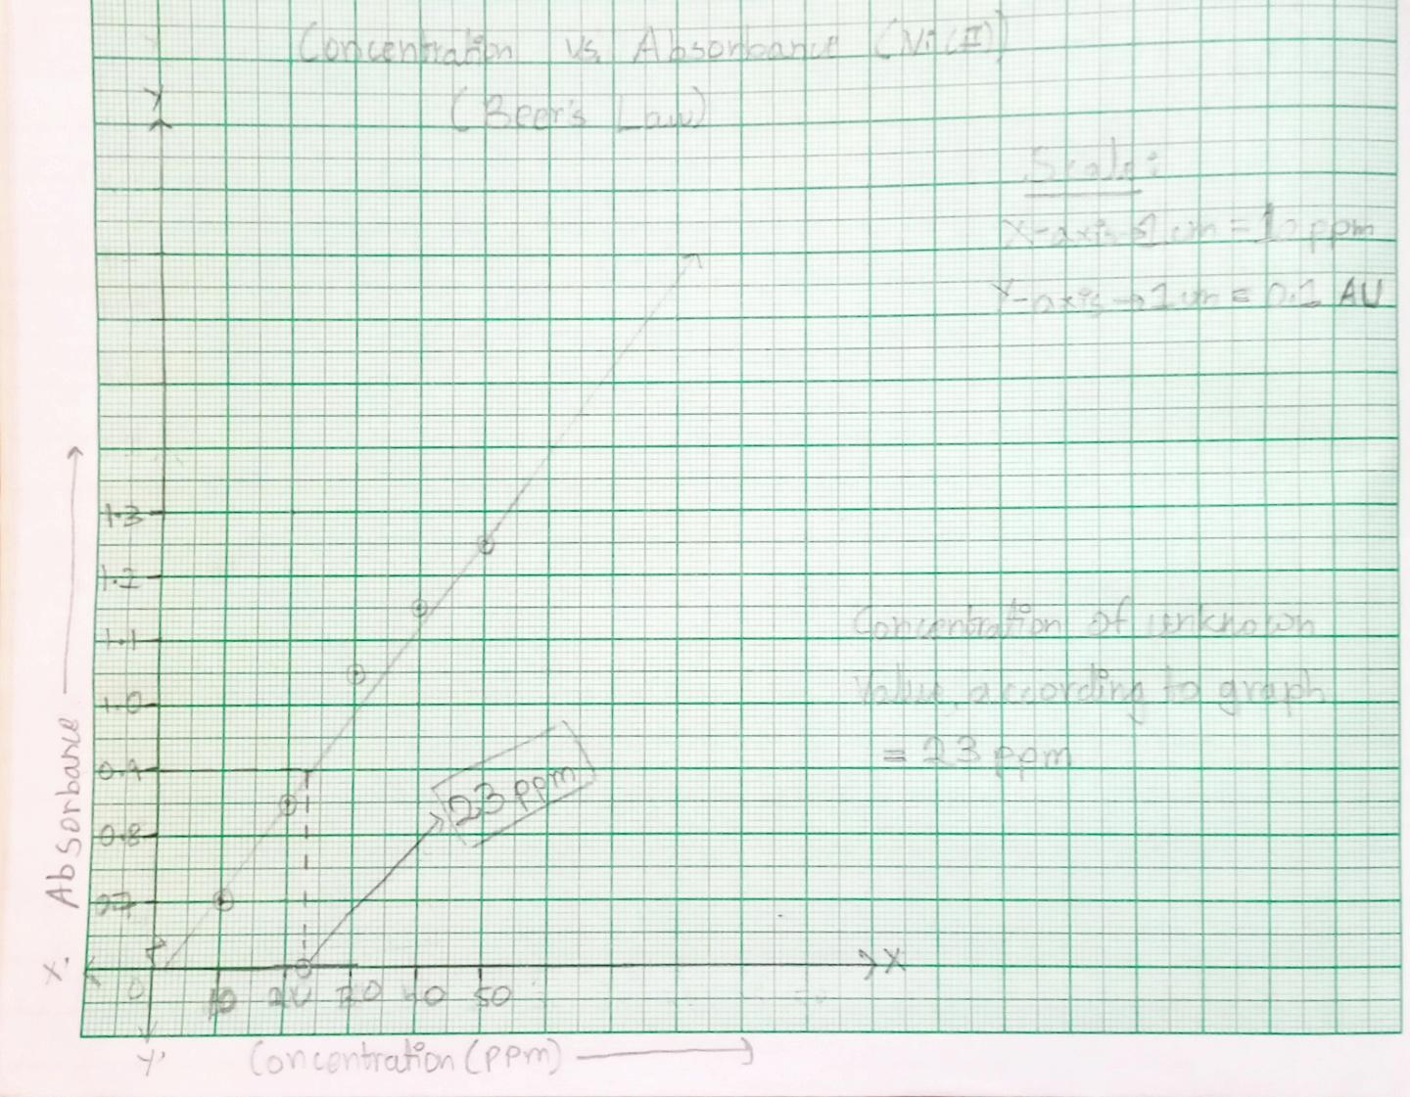**Graph:**

**Result:**

Concentration of nickel in the given sample, as estimated by

1. Conventional method = **23 ppm (mg/L)**